# 



**Snowell Electric**

**Documentation**

|  |  |
| --- | --- |
| **Authors** | **C2311L- Group 1** |
| **Student1539442- Vũ Việt Hoàng**  **Student1540030- Đào Quốc Vương**  **Student1540012- Đỗ Hoàng Linh**  **Student1529023- Nguyễn Đức Hiệp** |
| **Date** | **17/10/2024** |
| **Instructor** | **Lục Văn Tiến** |

Hanoi, 17/10/2024

**Index**

1. Problem Definition 4

**1.1. Problem Abstraction 4**

**1.2. The Current System 5**

**1.3. The Proposed System 5**

**1.4. Users of the System 6**

**1.5. System functions 7**

**1.5.1. Register 7**

**1.5.2. Log In 8**

**1.5.3. Home 9**

**1.5.4. Shop Categories 10**

**1.5.5. My Cart 11**

**1.5.6. Admin 12**

2. System Designs 13

**2.1. Entity Relationship Diagram 13**

**2.2. Database Design 15**

**2.2.1. tbl_categories 16**

**2.2.2. tbl_customers 16**

**2.2.3. tbl_images 16**

**2.2.4. tbl_orders 17**

**2.2.5. tbl_orders_details 17**

**2.2.6. tbl_permissions 17**

**2.2.7. tbl_products 18**

**2.2.8. tbl_roles 18**

**2.2.9. tbl_suppliers 18**

**2.2.10. tbl_roles_permissions 19**

**2.2.11. tbl_userroles 19**

**2.2.12. tbl_users 19**

**2.3. Sitemap 20**

**2.4. System fucntions design 21**

**2.4.1. Resgistration and Login 21**

**2.4.2. Checkout 22**

**2.5.Task sheet 24**

3. Code. 26

**3.1. HomePages: 26**

**3.2. ProductPages: 26**

**3.3. Contact Us 27**

**3.4. My Cart 27**

**3.5. login and register 28**

**3.6. User profile 28**

# Problem Definition

## 1.1. Problem Abstraction

Clarins is a skincare brand for the face and body from France. With a genuine passion for providing natural and authentic beauty solutions, this brand began with a beauty spa and its own product line. With over 60 years of experience in the industry and close interactions with customers, Clarins has become an icon in the field of premium beauty, offering a wide range of skincare solutions for the face and body, makeup, and fragrances. Some of the standout iconic products in their range include various facial oils, the unique Double Serum, and body care treatments that represent the essence of the brand—each product reflecting the professionalism and top-tier effectiveness of Clarins' beauty solutions.

Clarins has been and continues to provide innovative, plant-based solutions. The goal remains unchanged: to seek unique solutions for individual customers. Clarins not only delivers outstanding results but also provides a delightful sensory experience. To achieve this, the product formulas incorporate the best essences from the plant world.

In addition to offering their own products, they also provide products from various other brands on their website. This helps their customers find comprehensive solutions for all skincare and beauty products available on the market.

Your task is to create a Single-Page Application and a Website that meets the specifications below. The website must work well across all major browsers, including Chrome, IE, Firefox, etc.

## 1.2. The Current System

The header of the page must feature an appropriate logo and images of beauty products.

The website must contain various sections such as FACE, BODY, SUNSCREEN, HAIR, MAKEUP, PERFUMES, etc., with products displayed in these sections.

Clicking on a product will open a pop-up window with detailed information and pricing for the product, along with scrollable images.

A filter must be provided based on brand, price, product type, etc.

There should be a section displaying different offers on products.

Best-selling products should be displayed at the top section.

A gallery can be added to view different images.

Links to the Site map, Gallery, About Us, and Contact Us must be included.

About Us and Contact Us: This menu option must display the organization's email, address, and contact phone number.

In addition to the above, the portal must implement the following functionalities:

Display a continuously scrolling ticker at the bottom of the page with the current date, time, and location (suggestion: use the geolocation feature of HTML5).

Display the number of visitors in the upper right corner of the page next to the logo image.

Menu options must change color on hover and after being clicked.

Fade-in and fade-out effects can be used for the menus.

## 1.3. The Proposed System

The new system we are building will be a comprehensive online platform for the Snowell Electric website, providing similar, shopping and convenient experiences for customers. The following are the main functions of the system:

**a**. **Product:** Product category - this will be where users search for products. The title ba r displays product categories available on the web, including:

- Consumer Electronics

- Home Appliances

- Cooling devices

- Audio Equipment

- Lighting Devices

**b.** **The Search bar**: When the user selects a category, the products of that category will display below the title bar. If users want to choose a specific product, they can enter information related to the product into the search bar, and that product will be displayed directly.

**c.** **Contact us**: like the contact page, this category will provide contact information, contact forms as well as store address.

**d.** **My Cart** (Cart): This category allows users to check products in the shopping cart to proceed with payment or add/delete products.

**e.** **Login**: This category depending on the account can be for website administrators to update the latest product information and edit website details or for buyers to save their information for convenient shopping.**f. Forget password**: This category allows customers to reset their password via email or other authentication methods when they are unable to access their account.

**g. Accessing**: This notes the number of users currently accessing the sit

. Customer Requirements Specification

## 1.4. Users of the System

Customer: purchases electronic products.

Admin: Manages the website and product listings.

Guest: Browse the website without logging in.

The usages of the website to the clients:

Browsing products: explore a range of electronic with categories and filters.

Viewing product details: access detailed product info, specs, pricing and reviews.

Account management: create / manage accounts, update info and view purchase history.

Shopping cart: add / update / remove items with cart retention for logged-in users.

Check-out process: secure checkout with multiple payment options and order review.

Order tracking and history: track orders and access order history with detailed summaries.

Customer reviews and ratings: leave and read product reviews and ratings.

## 1.5. System functions

### **1.5.1. Register**

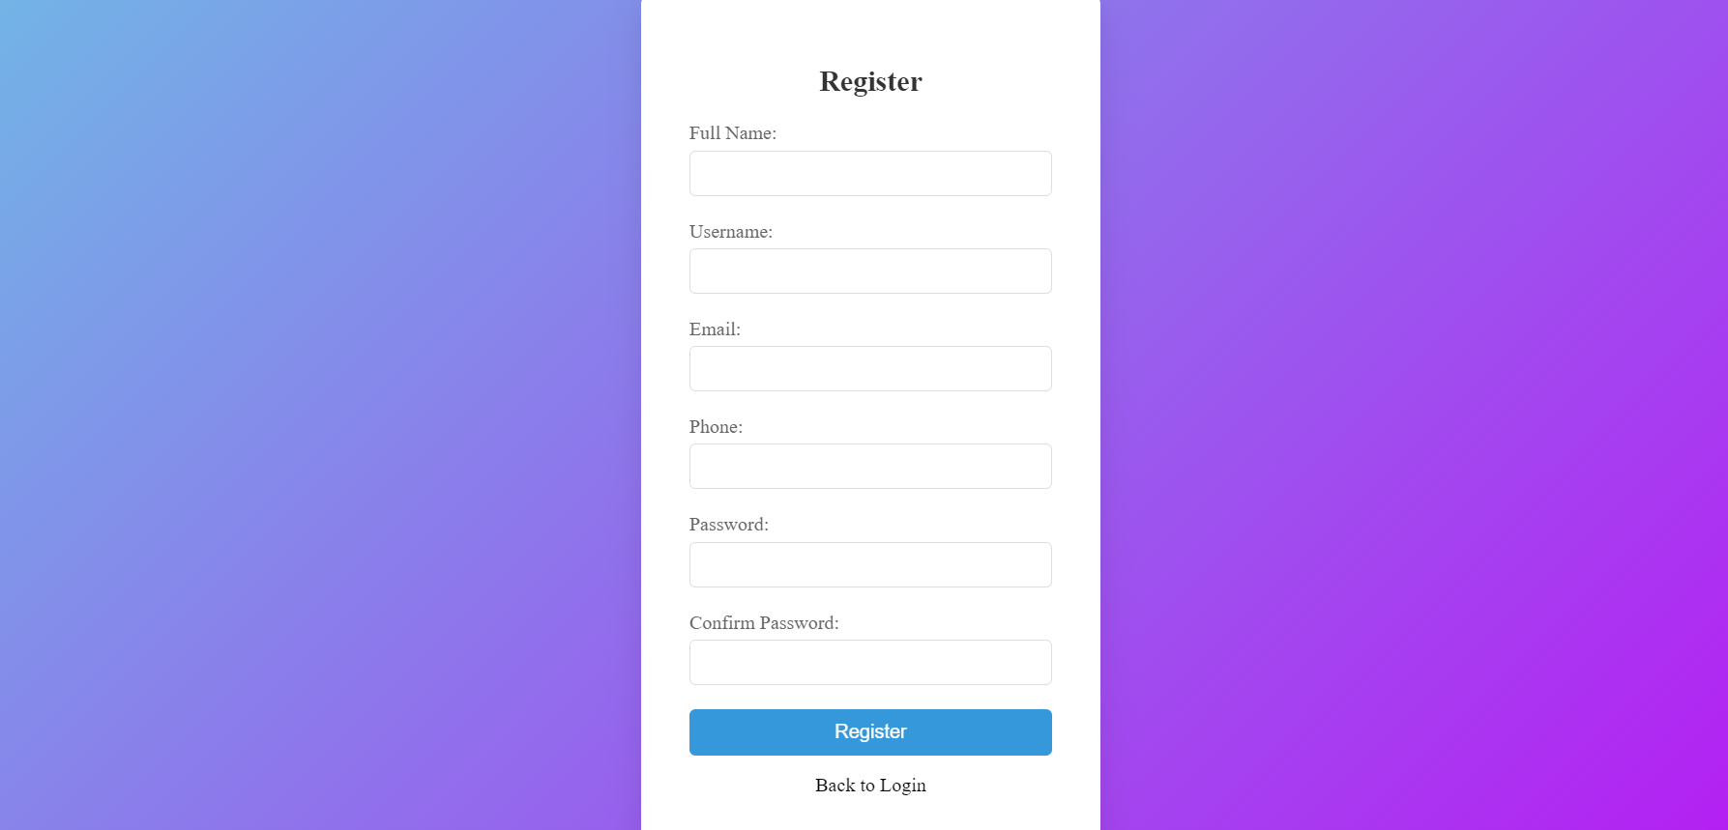

Display registration interface.

There are 6 pieces of information, that the user needs to enter.

Performs data validation in cells:

The username and password need to have more than 3 characters.

The password needs to be confirmed.

The email and phone number need to be in the correct format.

Click the “Signup” button to register. If the above requirements are wrong or information doesn’t unique, an error message will be displayed.

### **1.5.2. Log In**

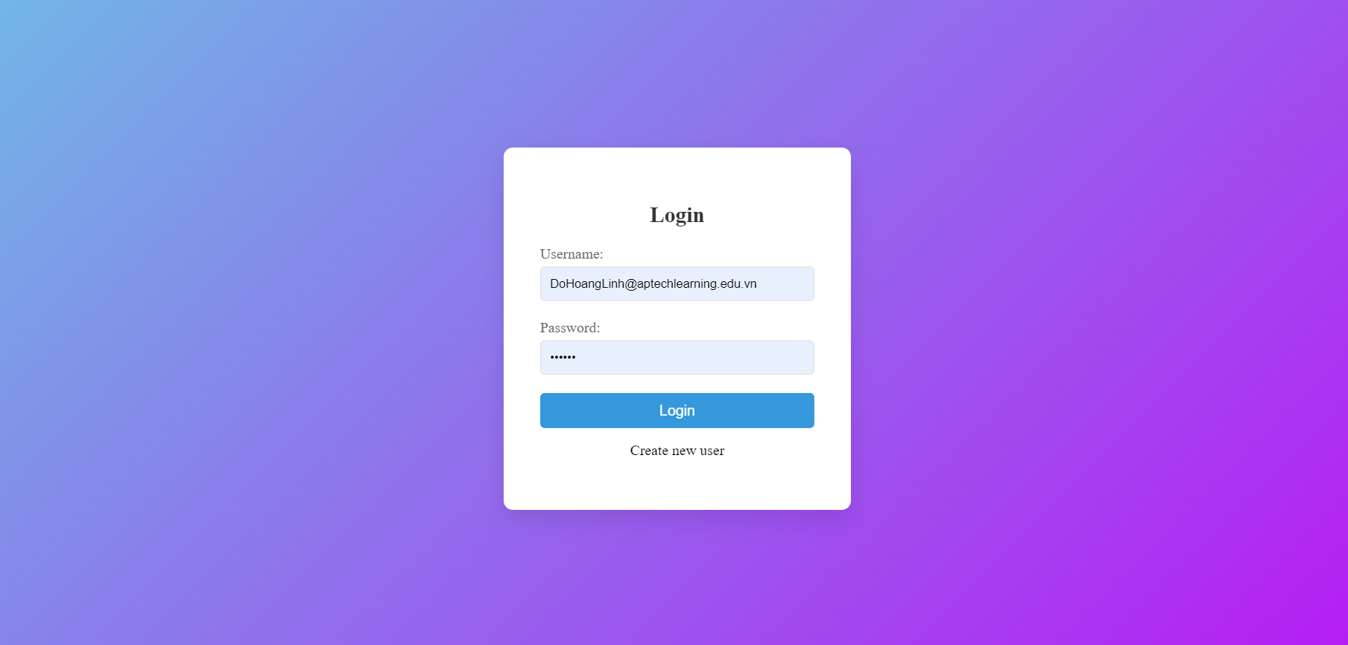

**Username**:

The user enters their email address or username in this field.

**Password**:

The user inputs their corresponding account password.

**Login Button**:

Upon clicking the "Login" button, the form will validate the entered information (username and password).

If the information is correct, the user will be redirected to the system's main page or dashboard.

If the information is incorrect, an error message will appear, prompting the user to check their credentials.

**Create new user**:

This link allows users to create a new account if they don't already have one.

By clicking this link, the user will be directed to the registration page to sign up.

### **1.5.3. Home**

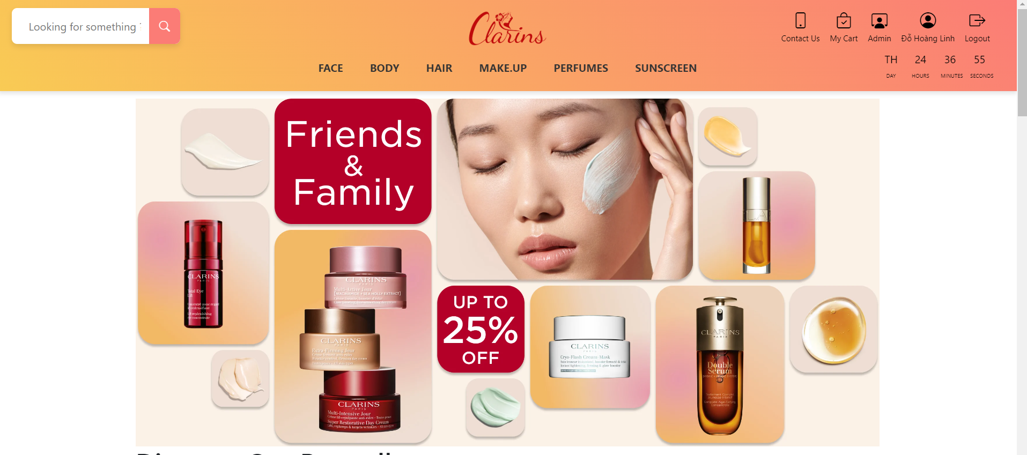

Appears to be a webpage promoting Clarins products with the theme "Friends & Family" and a discount offer. The content includes:

Search bar at the top left, with the placeholder text "Looking for something?"

Clarins logo in the center of the top section.

Navigation menu with categories such as FACE, BODY, HAIR, MAKEUP, PERFUMES, SUNSCREEN.

In the top right corner, there are interactive icons including "Contact Us," "My Cart," "Admin," the user's name "Đỗ Hoàng Linh," and "Logout." A countdown timer is also displayed showing days, hours, minutes, and seconds.

The main section of the page features an image of a woman applying cream, alongside various Clarins skincare products such as serums, creams, masks, and more.

The text "Friends & Family" stands out in white on a red background, along with a promotional offer "Up to 25% Off."

### **1.5.4. Shop Categories**

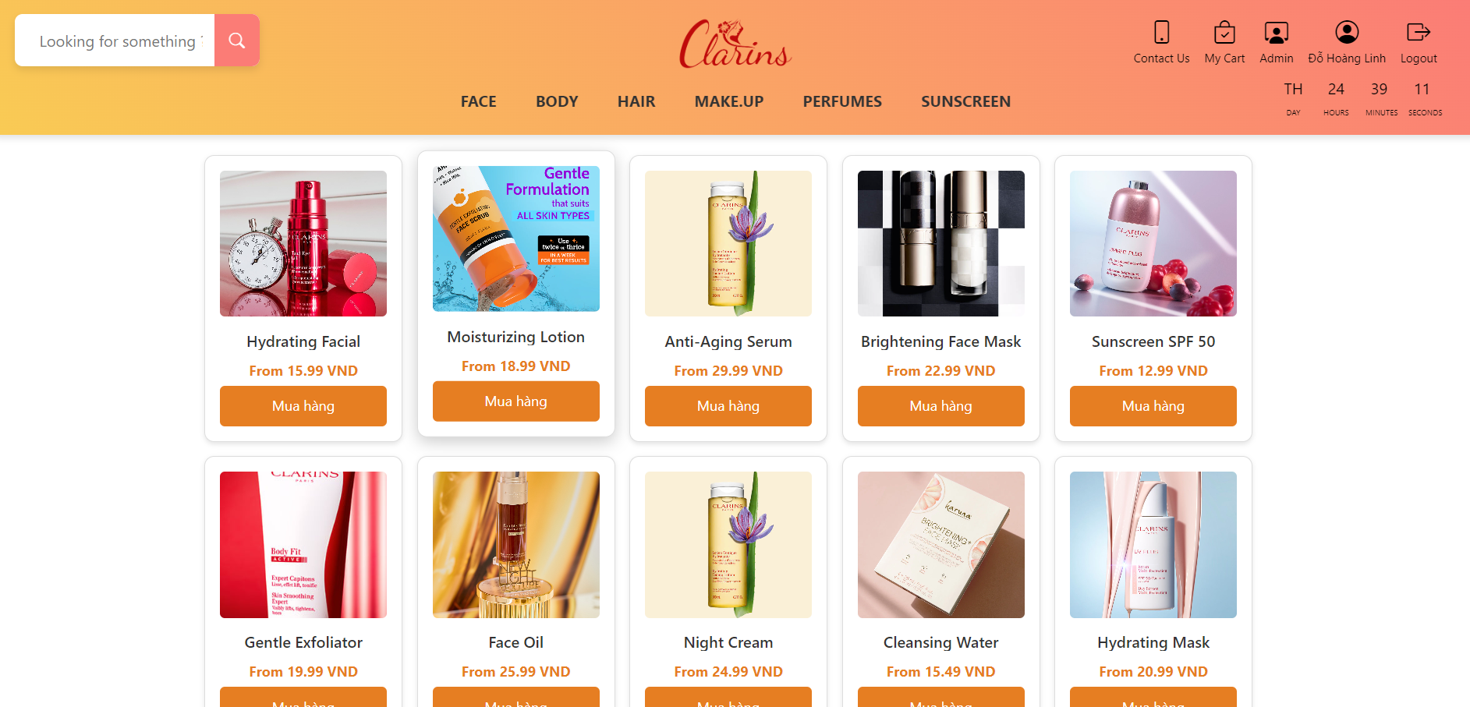

Key features of the page:

The page displays products under the Face category (facial skincare).

Each product is clearly shown with an image, product name, and price. Some notable products include:

Hydrating Facial Cleanser: A moisturizing face cleanser.

Moisturizing Lotion: A hydrating lotion.

Anti-Aging Serum: An anti-aging serum.

Brightening Face Mask: A brightening face mask.

Sunscreen SPF 50: Sunscreen with SPF 50.

Other products such as exfoliators, face oils, night creams, cleansing water, and hydrating masks are also listed.

Each product has an orange "Mua hàng" (Buy Now) button beneath it, allowing users to quickly add items to their cart or proceed with a purchase.

Prices are displayed as "From [amount] VND," indicating the starting price for each product.

This page is focused on facial skincare products and provides a simple, quick overview for customers to explore and shop.

### **1.5.5. My Cart**

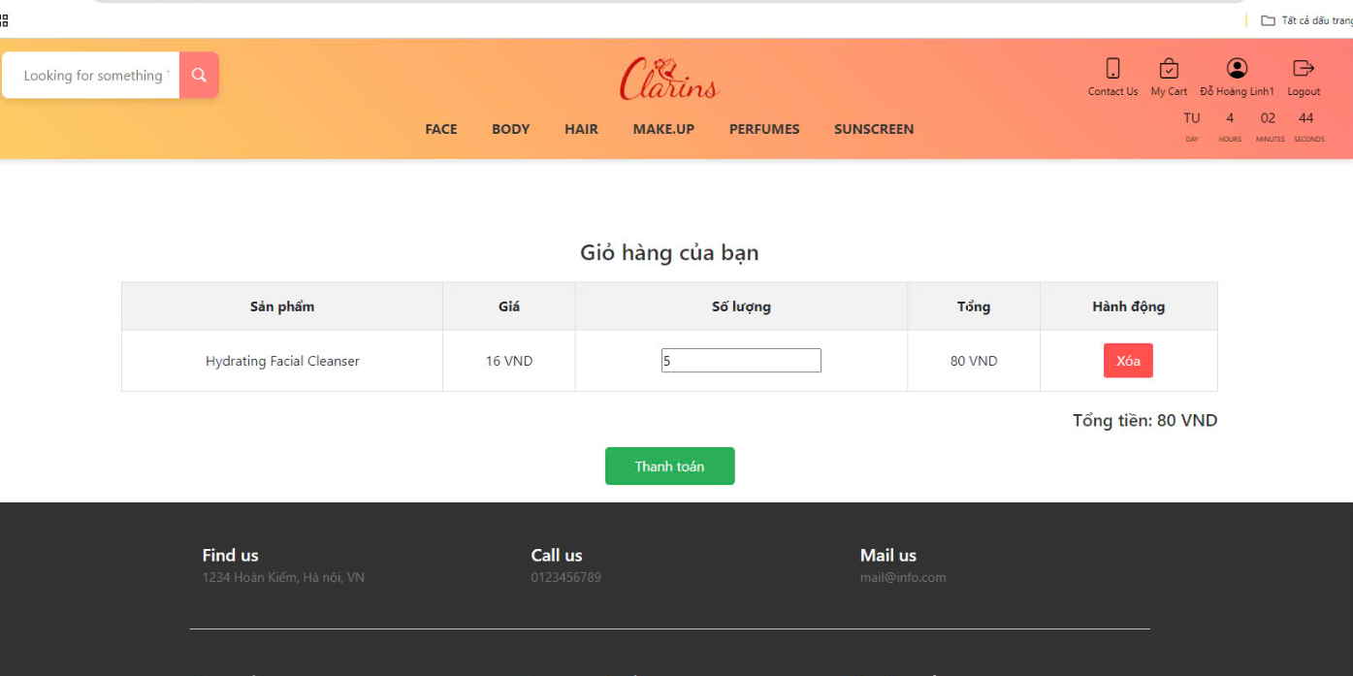

The image shows a shopping cart page for Clarins, a beauty and skincare brand. The interface includes the following details:

Product, Price, Quantity , (calculated based on the quantity and unit price).Action: A red button labeled "Xóa" allows the user to remove the item from the cart. At the bottom, the total amount is shown VND, and there is a green button labeled "Thanh toán" (meaning "Checkout") for completing the purchase.

The page header includes navigation options for Face, Body, Hair, Makeup, Perfumes, and Sunscreen, along with a search bar and user account-related links (like My Cart, Contact Us, and Logout). There is also a countdown timer indicating "TU" (likely time left for something).

### **1.5.6. Admin**

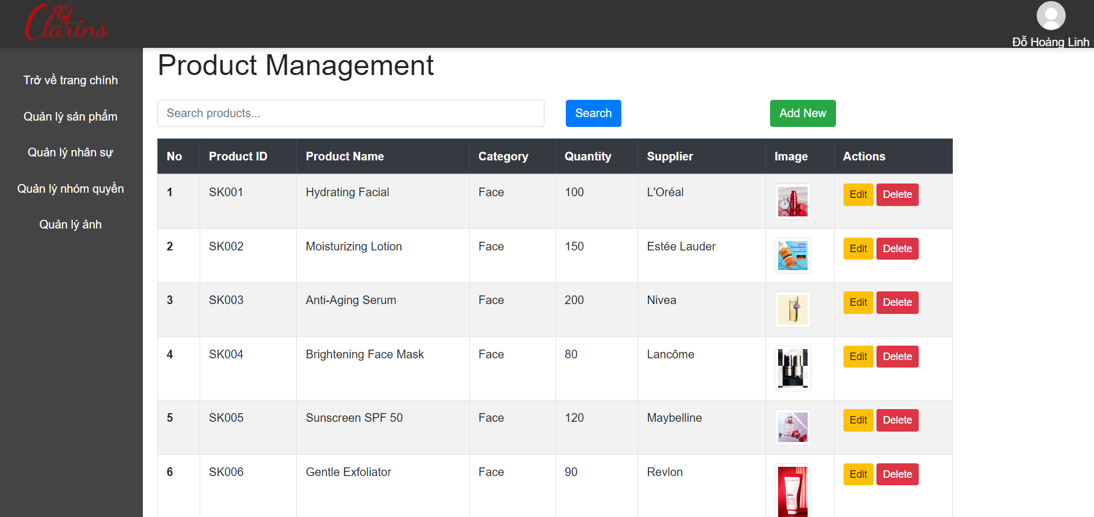

product management page of a system, with the following details:

Main title in the center reads "Product Management."

Search bar right below the title, allowing users to search for products. There's a blue "Search" button and a green "Add New" button to add new products.

Product list displayed in a table with columns:

No: Serial number.

Product ID: The product's ID.

Product Name: The name of the product.

Category: The category (in this case, all products are under "Face").

Quantity: The amount of stock remaining.

Supplier: The supplier of the product.

Image: A product image thumbnail.

Actions: Buttons for "Edit" (yellow) and "Delete" (red).

Navigation menu on the left with options:

Return to home page

Product management

Human resources management

Role management

Image management

In the top-right corner, the logged-in user's name "Đỗ Hoàng Linh" is displayed.

# 2. System Designs

## 2.1. Entity Relationship Diagram

With the objective of creating a website that integrates information provision with e-commerce, we identify the entities that the website needs:

* Homepage:

- Header:

+ Search Bar

+ MyCart

+ Login

+ Contact Us

- List categories Products

+ Face

+ Body

+ Hair

+ Make.Up

+ PerFuMes

+ SunScreen

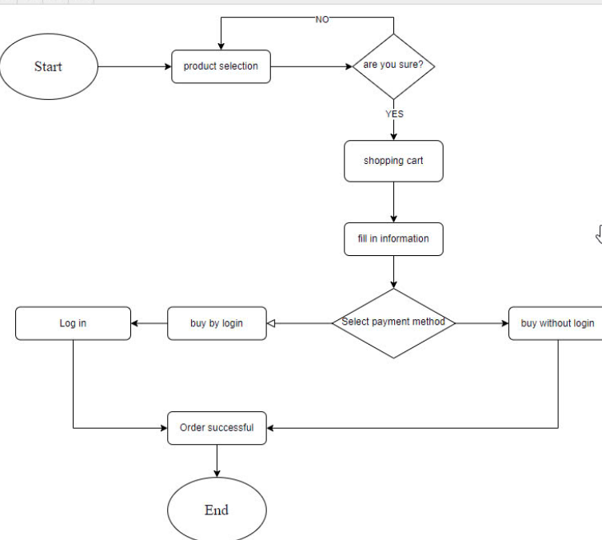

## 

## 2.2. Database Design

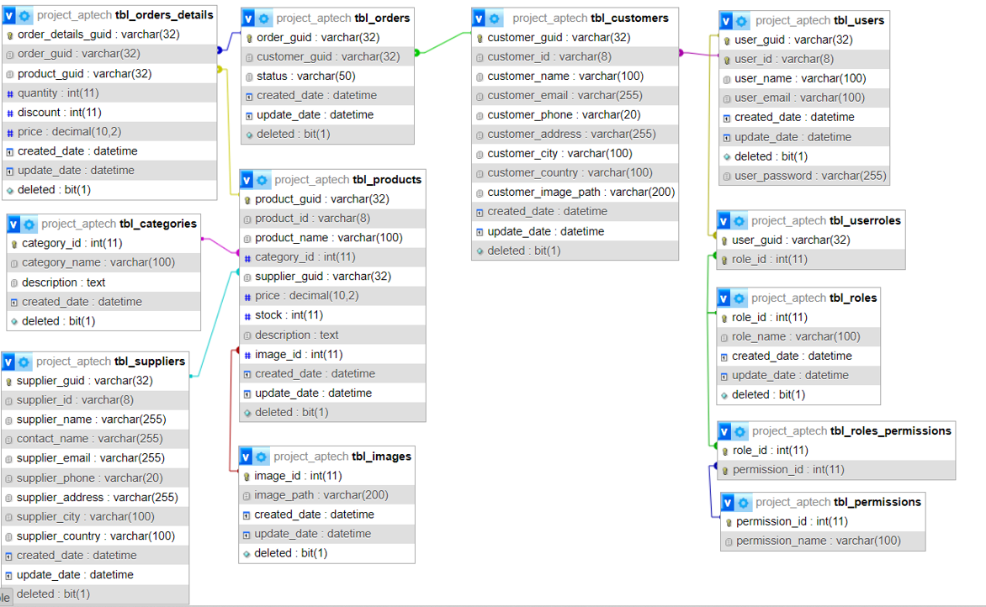

**2.2.1. tbl_categories**

|  |  |  |  |  |
| --- | --- | --- | --- | --- |
| Column | Type | Null | Default | Comments |
| category_id | int(11) | No |  | Category ID |
| category_name | varchar(100) | Yes | NULL | Category name |
| Description | text | Yes | NULL | Description |
| created_date | datetime | Yes | current_timestamp() | Creation date |
| Deleted | bit(1) | Yes | NULL | Deleted (flag) |

**2.2.2. tbl_customers**

|  |  |  |  |  |
| --- | --- | --- | --- | --- |
| Column | Type | Null | Default | Comments |
| customer_guid | varchar(32) | No |  | Customer MD5 ID |
| customer_id | varchar(8) | Yes | NULL | Customer identifier |
| customer_name | varchar(100) | Yes | NULL | Customer name |
| customer_email | varchar(255) | Yes | NULL | Customer email |
| customer_phone | varchar(20) | Yes | NULL | Customer phone number |
| customer_address | varchar(255) | Yes | NULL | Customer address |
| customer_city | varchar(100) | Yes | NULL | City |
| customer_country | varchar(100) | Yes | NULL | Country |
| customer_image_path | varchar(200) | Yes | NULL | Avatar |
| created_date | datetime | Yes | current_timestamp() | Creation date |
| update_date | datetime | Yes | current_timestamp() | Update date |
| Deleted | bit(1) | Yes | NULL | Deleted (flag) |

### **2.2.3. tbl_images**

|  |  |  |  |  |
| --- | --- | --- | --- | --- |
| Column | Type | Null | Default | Comments |
| image_id | int(11) | No |  | Image ID |
| image_path | varchar(200) | Yes | NULL | Image path |
| created_date | datetime | Yes | current_timestamp() | Creation date |
| update_date | datetime | Yes | current_timestamp() | Update date |
| Deleted | bit(1) | Yes | NULL | Deleted (flag) |

**2.2.4. tbl_orders**

|  |  |  |  |  |
| --- | --- | --- | --- | --- |
| Column | Type | Null | Default | Comments |
| order_guid | varchar(32) | No |  | Order ID (GUID) |
| customer_guid | varchar(32) | Yes | NULL | Customer GUID |
| Status | varchar(50) | Yes | NULL | Order status |
| created_date | datetime | Yes | current_timestamp() | Creation date |
| update_date | datetime | Yes | current_timestamp() | Ngày sửa |
| Deleted | bit(1) | Yes | NULL | xóa |

### **2.2.5. tbl_orders_details**

|  |  |  |  |  |
| --- | --- | --- | --- | --- |
| Column | Type | Null | Default | Comments |
| order_details_guid | varchar(32) | No |  | Order details ID (GUID) |
| order_guid | varchar(32) | Yes | NULL | Order GUID |
| product_guid | varchar(32) | Yes | NULL | Product GUID |
| Quantity | int(11) | Yes | NULL | Quantity |
| Discount | int(11) | Yes | NULL | Discount |
| Price | decimal(10,2) | Yes | NULL | Price |
| created_date | datetime | Yes | current_timestamp() | Creation date |
| update_date | datetime | Yes | current_timestamp() | Update date |
| Deleted | bit(1) | Yes | NULL | Deleted (flag) |

**2.2.6. tbl_permissions**

|  |  |  |  |  |
| --- | --- | --- | --- | --- |
| Column | Type | Null | Default | Comments |
| permission_id | int(11) | No |  | Permission ID |
| permission_name | varchar(100) | Yes | NULL | Permission name |

**2.2.7. tbl_products**

|  |  |  |  |  |
| --- | --- | --- | --- | --- |
| Column | Type | Null | Default | Comments |
| product_guid | varchar(32) | No |  | Product MD5 ID |
| product_id | varchar(8) | Yes | NULL | Product identifier |
| product_name | varchar(100) | Yes | NULL | Product name |
| category_id | int(11) | Yes | NULL | Category ID |
| supplier_guid | varchar(32) | Yes | NULL | Supplier GUID |
| Price | decimal(10,2) | Yes | NULL | Price |
| Stock | int(11) | Yes | NULL | Stock |
| Description | text | Yes | NULL | Description |
| image_id | int(11) | Yes | NULL | Image ID |
| created_date | datetime | Yes | current_timestamp() | Creation date |
| update_date | datetime | Yes | current_timestamp() | Update date |
| Deleted | bit(1) | Yes | NULL | Deleted (flag) |

**2.2.8. tbl_roles**

|  |  |  |  |  |
| --- | --- | --- | --- | --- |
| Column | Type | Null | Default | Comments |
| role_id | int(11) | No |  | Role ID |
| role_name | varchar(100) | Yes | NULL | Role name |
| created_date | datetime | Yes | current_timestamp() | Creation date |
| update_date | datetime | Yes | current_timestamp() | Update date |
| Deleted | bit(1) | Yes | NULL | Deleted (flag) |

### **2.2.9. tbl_suppliers**

|  |  |  |  |  |
| --- | --- | --- | --- | --- |
| Column | Type | Null | Default | Comments |
| supplier_guid | varchar(32) | No |  | Supplier MD5 ID |
| supplier_id | varchar(8) | Yes | NULL | Supplier identifier |
| supplier_name | varchar(255) | Yes | NULL | Supplier name |
| contact_name | varchar(255) | Yes | NULL | Contact person name |
| supplier_email | varchar(255) | Yes | NULL | Supplier email |
| supplier_phone | varchar(20) | Yes | NULL | Supplier phone number |
| supplier_address | varchar(255) | Yes | NULL | Supplier address |
| supplier_city | varchar(100) | Yes | NULL | Supplier city |
| supplier_country | varchar(100) | Yes | NULL | Supplier country |
| created_date | datetime | Yes | current_timestamp() | Creation date |
| update_date | datetime | Yes | current_timestamp() | Update date |
| Deleted | bit(1) | Yes | NULL | Deleted (flag) |

**2.2.10. tbl_roles_permissions**

|  |  |  |  |  |
| --- | --- | --- | --- | --- |
| Column | Type | Null | Default | Comments |
| role_id | int(11) | No |  |  |
| permission_id | int(11) | No |  |  |

**2.2.11. tbl_userroles**

|  |  |  |  |  |
| --- | --- | --- | --- | --- |
| Column | Type | Null | Default | Comments |
| user_guid | varchar(32) | No |  |  |
| role_id | int(11) | No |  |  |

### **2.2.12. tbl_users**

|  |  |  |  |  |
| --- | --- | --- | --- | --- |
| Column | Type | Null | Default | Comments |
| user_guid | varchar(32) | No |  | User MD5 ID |
| user_id | varchar(8) | No |  | User identifier |
| user_name | varchar(100) | Yes | NULL | User name |
| user_email | varchar(100) | Yes | NULL | User email |
| user_password | varchar(255) | No |  | User password |
| created_date | datetime | Yes | current_timestamp() | Creation |
| user_guid | varchar(32) | No |  | User MD5 ID |
| user_id | varchar(8) | No |  | User identifier |

## 2.3. Sitemap



## 2.4. System fucntions design

### **2.4.1. Resgistration and Login**

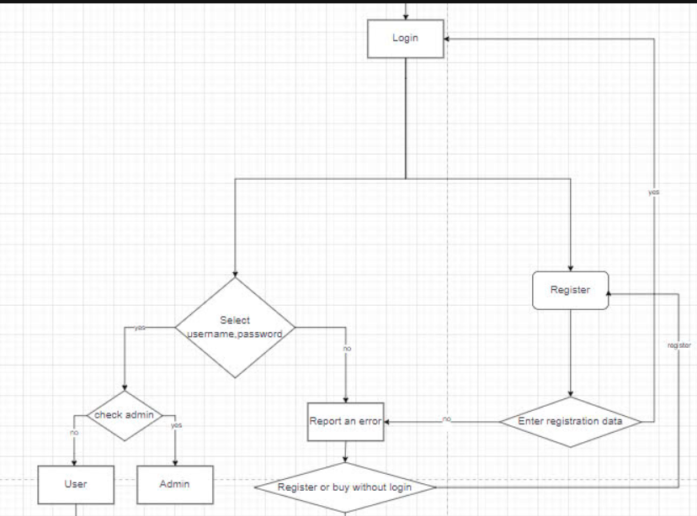

### **2.4.2. Checkout**

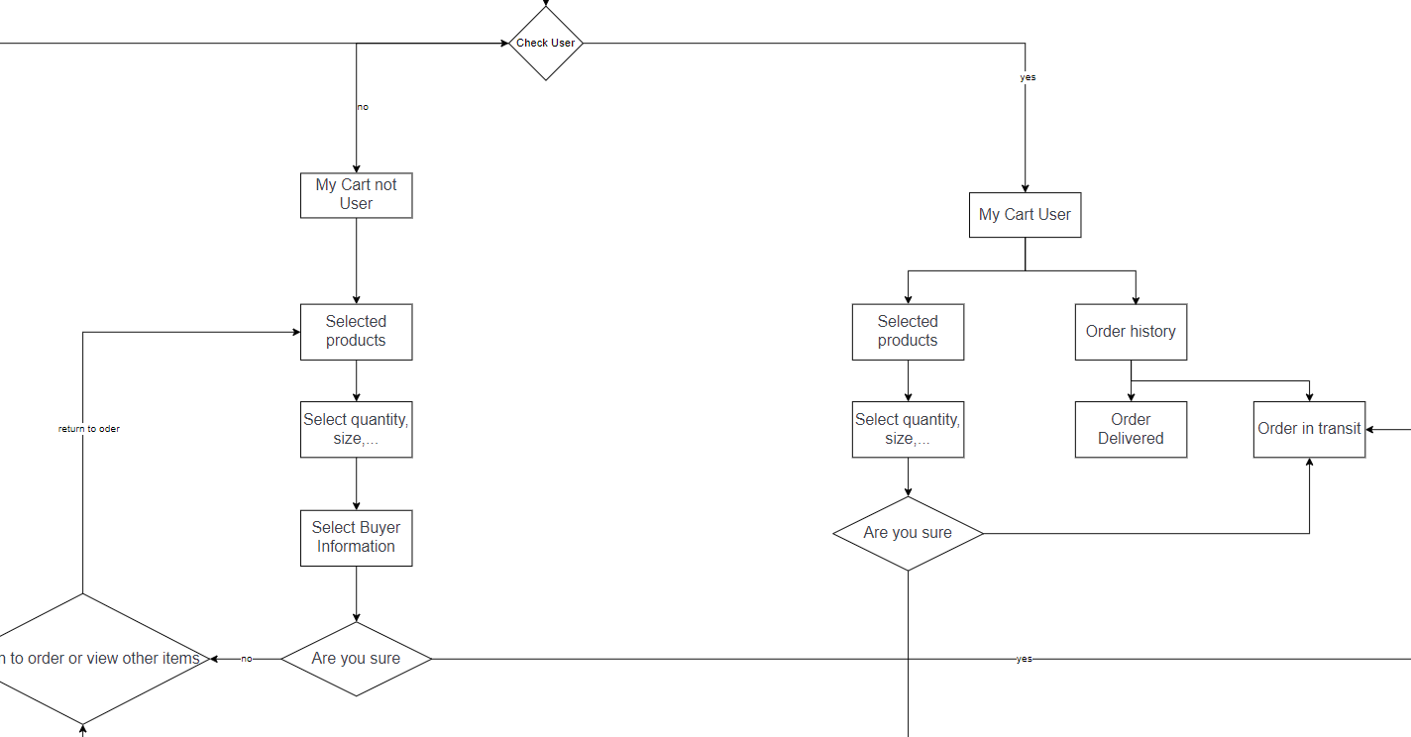

# 

**2.4.3. Search**

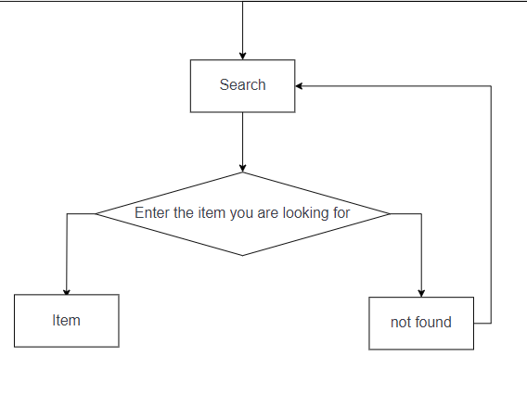

## 2.5.Task sheet

|  |  |  |  |  |
| --- | --- | --- | --- | --- |
| **Task** | **Start Time** | **Finish Time** | **Implemented by** | **Evaluation (%)** |
| **1. Analyze tasks** | 20/09/2024 | 24/09/2024 | Team | 100 |
| **2. Brainstorm the task** | 20/09/2024 | 24/09/2024 | Đào Quốc Vương | 100 |
| **3. I) Project Initialization** | 24/09/2024 | 28/09/2024 | Team | 100 |
| **4. a) Set Up Environment (install PHP, Laravel, ReactJS, git)** | 24/09/2024 | 26/09/2024 | Nguyễn Đức Hiệp | 33 |
| **5. b) Create Project Directory Structure, folder (backend, frontend, database)** | 24/09/2024 | 26/09/2024 | Đỗ Hoàng Linh | 33 |
| **6. c) Set Up Database (Create tables, constraints, primary key, foreign keys)** | 26/09/2024 | 28/09/2024 | Vũ Việt Hoàng | 33 |
| **7. II) Backend Development (Laravel) (Admin Dashboard, API React)** | 28/09/2024 | 05/10/2024 | Team | 100 |
| **7.1 Admin Dashboard** | 28/09/2024 | 01/10/2024 | Team | 100 |
| **7.2 a.1) Authentication & Authorization (backend)** | 28/09/2024 | 29/09/2024 | Đào Quốc Vương | 5 |
| **7.3 a.2) Authentication & Authorization (frontend-view)** | 29/09/2024 | 30/09/2024 | Đào Quốc Vương | 5 |
| **7.4 b.1) Category Management (backend)** | 28/09/2024 | 29/09/2024 | Đào Quốc Vương | 10 |
| **7.5 b.2) Category Management (frontend-view)** | 29/09/2024 | 30/09/2024 | Vũ Việt Hoàng | 5 |
| **7.6 c.1) Subcategory Management (backend)** | 28/09/2024 | 29/09/2024 | Đào Quốc Vương | 10 |
| **7.7 c.1) Subcategory Management (frontend-view)** | 29/09/2024 | 30/09/2024 | Đỗ Hoàng Linh | 5 |
| **7.8 d.1) Brand Management (backend)** | 28/09/2024 | 29/09/2024 | Đào Quốc Vương | 10 |
| **7.9 d.1) Brand Management (frontend-view)** | 29/09/2024 | 30/09/2024 | Nguyễn Đức Hiệp | 5 |
| **7.10 e.1) Product Management (backend)** | 28/09/2024 | 29/09/2024 | Đào Quốc Vương | 10 |
| **7.11 e.2) Product Management (frontend-view)** | 29/09/2024 | 30/09/2024 | Đào Quốc Vương | 5 |
| **7.12 f.1) Order Management (backend)** | 30/09/2024 | 01/10/2024 | Đào Quốc Vương | 10 |
| **7.13 f.2) Order Management (frontend-view)** | 30/09/2024 | 01/10/2024 | Đào Quốc Vương | 5 |
| **7.14 g.1) User Management (backend)** | 30/09/2024 | 01/10/2024 | Đào Quốc Vương | 10 |
| **7.15 g.1) User Management (frontend-view)** | 30/09/2024 | 01/10/2024 | Đào Quốc Vương | 5 |

# 3. Code.

## 3.1. HomePages:

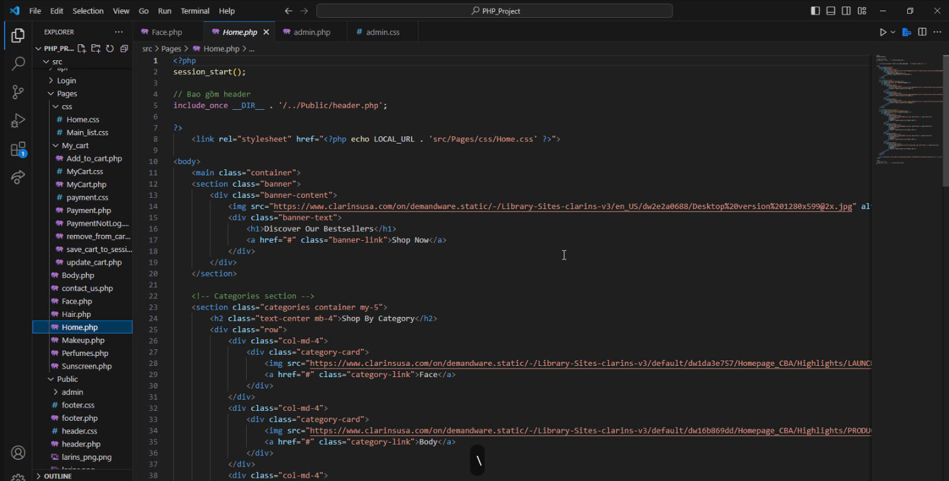

## 3.2. ProductPages:

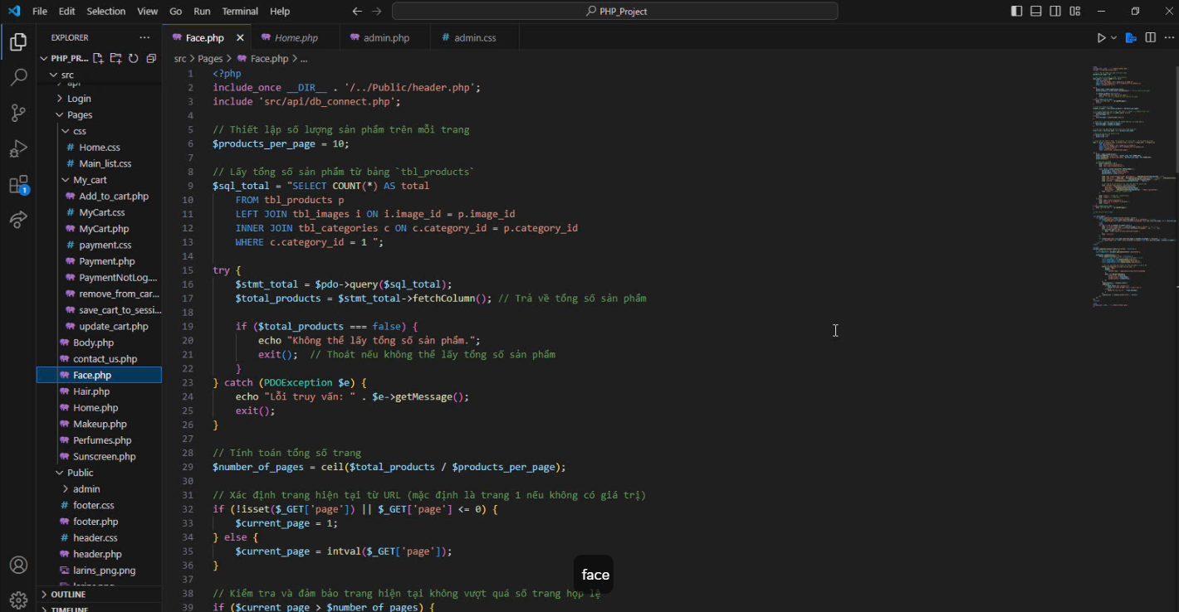

## 3.3. Contact Us

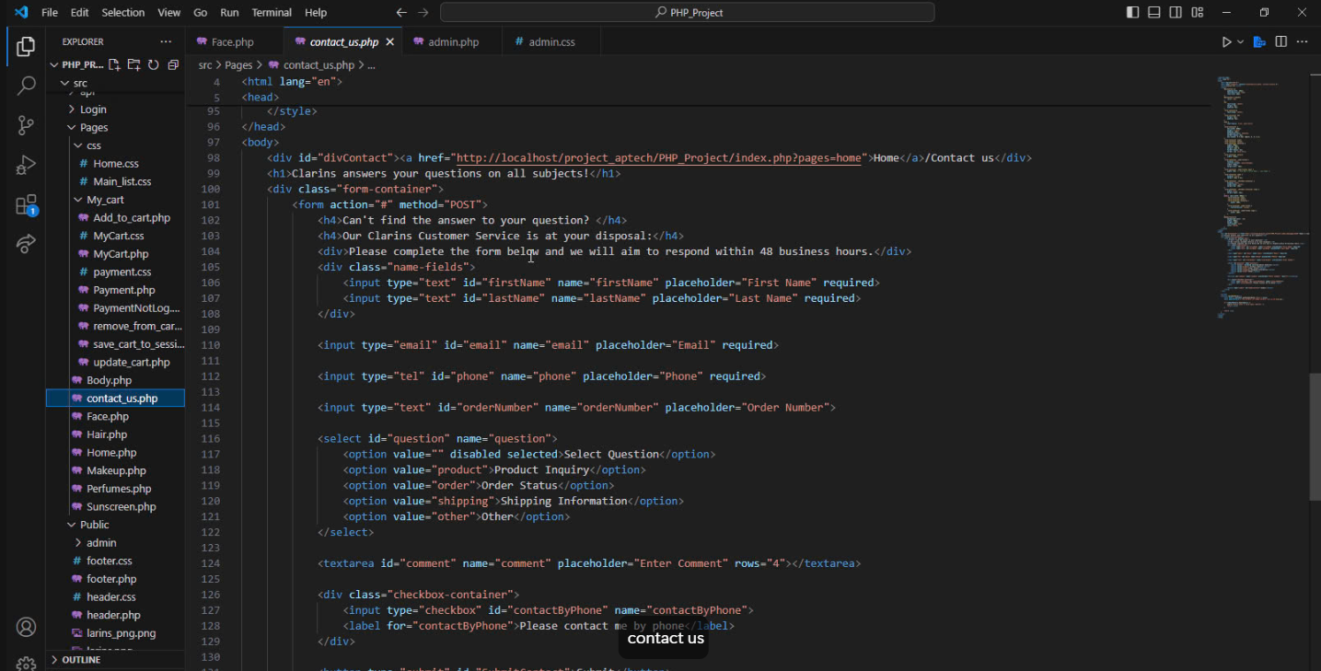

## 3.4. My Cart

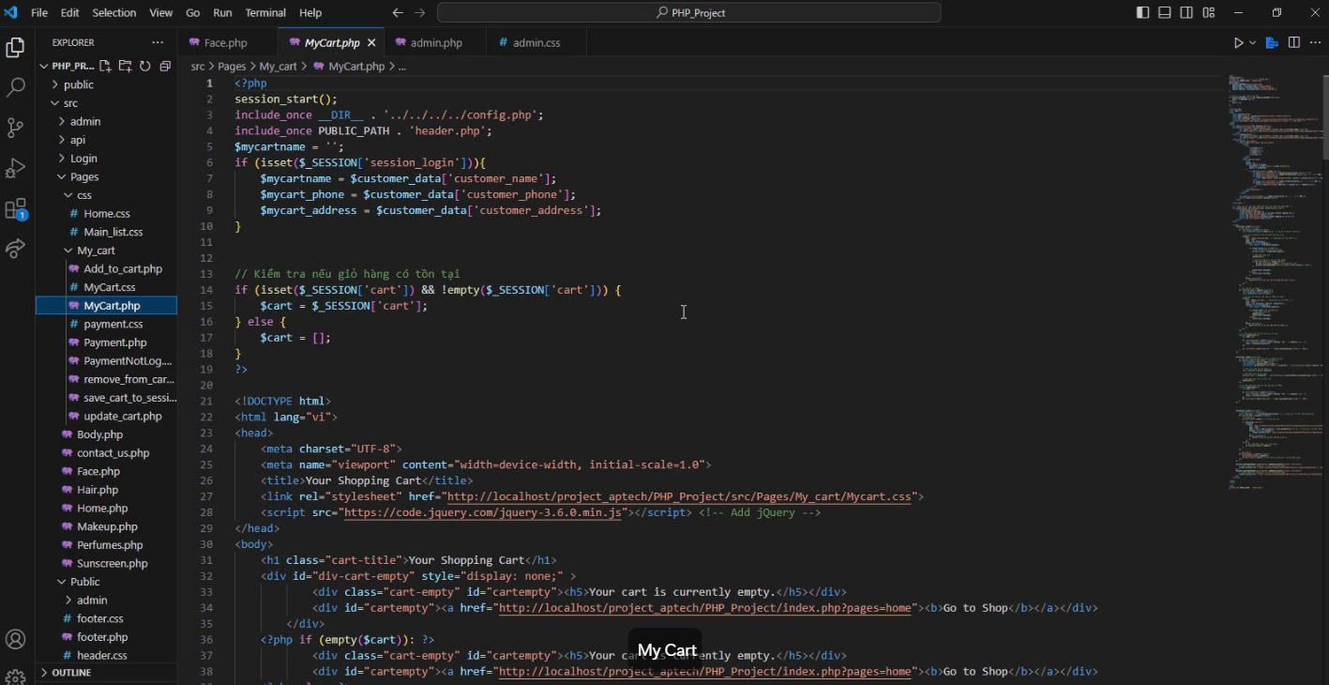

## 3.5. login and register

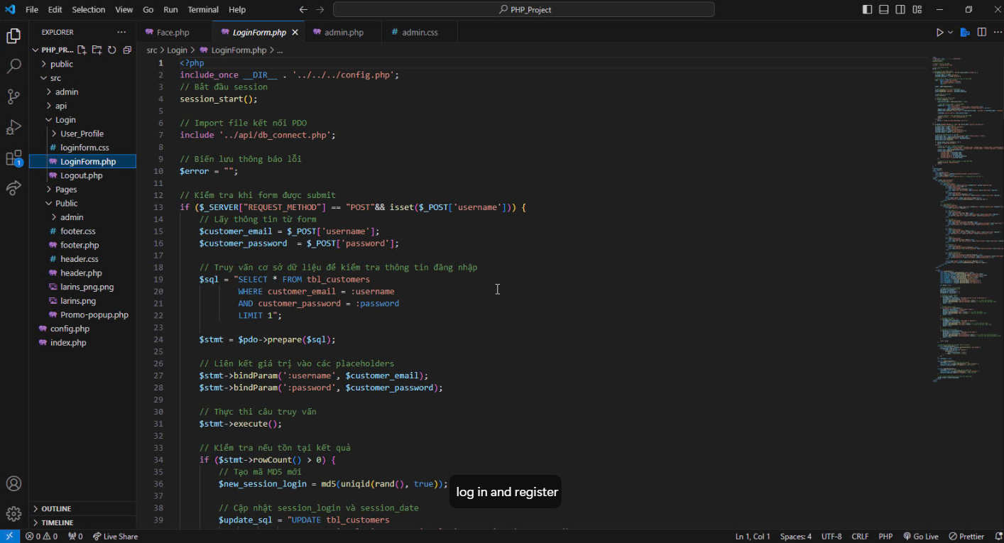

## 3.6. User profile

